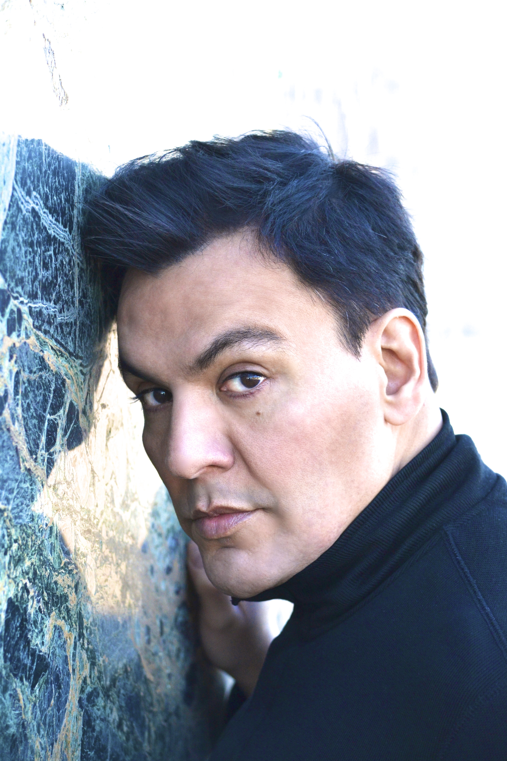
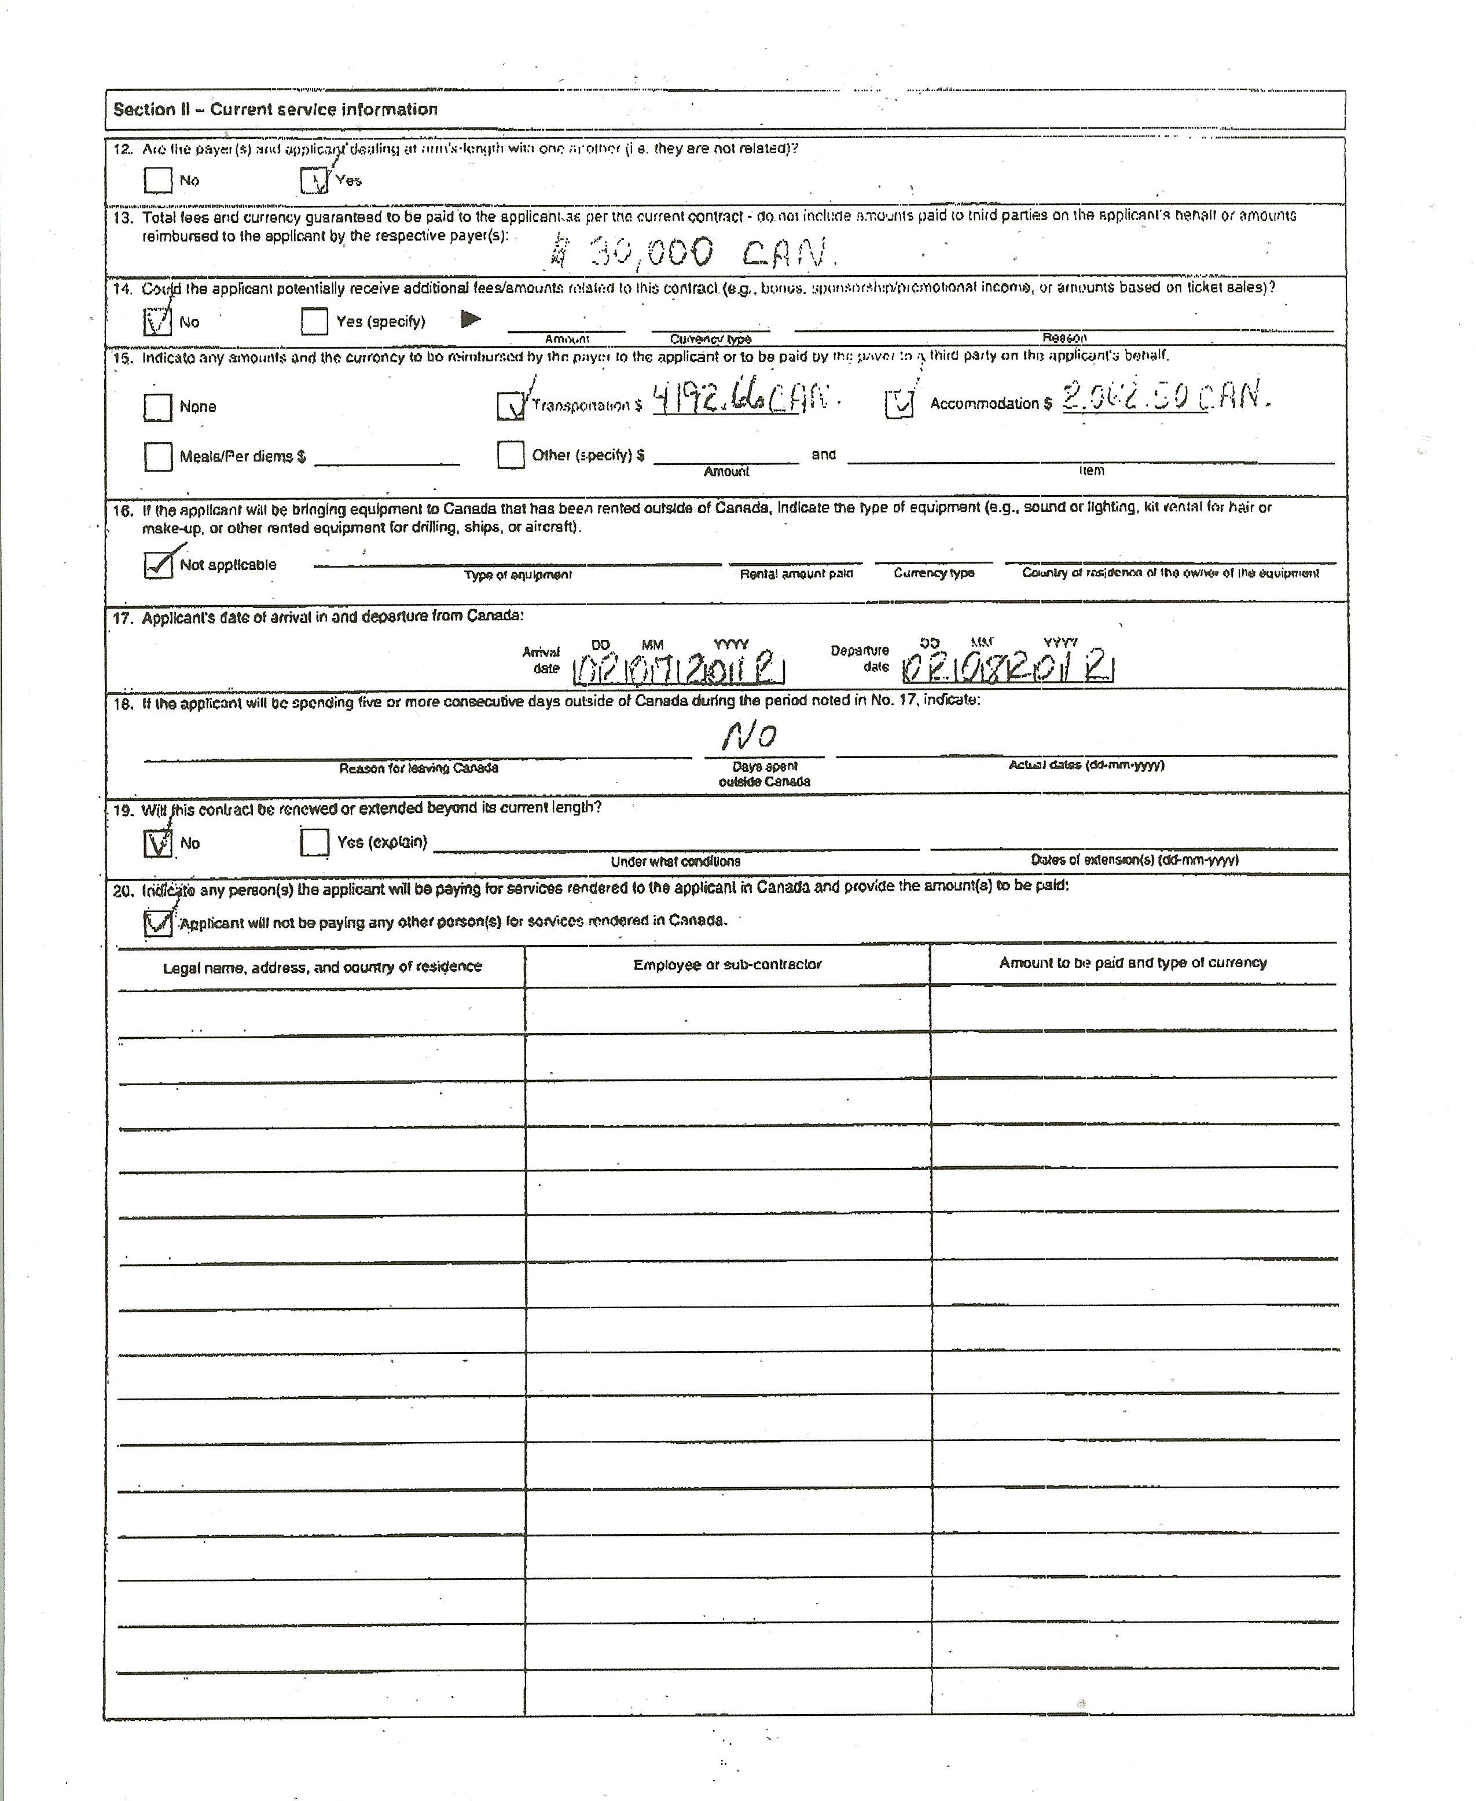
Rubin Casas has been declared “promising vocal material” by Opera News Magazine. His stentorian bass is one of great depth and beauty with a commanding stage persona.

In 2019 Rubin Casas joins Mid-America Productions at Carnegie Hall for Haydn’s, Mariazeller Mass No 8 as the bass soloist. He returns to the Opera Company of Middlebury as Scarpia in Tosca, followed by Il Bonzo (cover) in Madame Butterfly at the Metropolitan Opera and the Hermit in Der Freischütz with Heartbeat Opera. Upcoming engagements in 2020 include the Beethoven 9th Symphony with the Idaho Falls Symphony. In 2017 he returned to Virginia Opera for Samson et Dalila as Abimélech. He also sang Sparafucile in Rigoletto at Opera Las Vegas. In 2016, Casas “employed his dark voice expressively” for the role of Banco in Macbeth at the Opera Company of Middlebury and joined the Cedar Rapids Opera Theatre as the Commendatore in Don Giovanni with “rumbling bravura.”

Next, Casas joined the El Paso Opera for Tosca as Angelotti and Scrapia-cover. Casas’ 2014 season ends with the role of Colline in La Boheme at DiCapo Opera Theater. The Houston Chronicle described his Opera in the Heights portrayal in Lucia di Lammermoor as, “Rubin Casas delivered the chaplain Raimondo’s proclamations deeply and fully.” He was “a strong and imposing Bishop Ruiz” in Florentine Opera’s Grammy award winning-world premiere of Don Davis’ Rio de Sangre, recorded for commercial release on Albany Records. “Rubin Casas, as Bishop Ruiz, delivers a powerful, fervent confirmation service in Latin,” Opera News Magazine.

Casas returned to the New York City Opera for La Traviata in 2012 and, later in 2012-13 he sang Così fan tutte at Tacoma Opera and returned to the Opera Orchestra of New York in Andrea Chenier. 2011 marked his initial engagement with NYCO for Maurice Sendak’s Where the Wild Things Are. In 2010 he received the Austin Critic’s Table Award nomination for his winning portrayal of Eddie Carbone in A View From the Bridge at the Butler Opera Center for which he was called “powerful and expressive” by the Austin American Statesman. His 2009 Opera New Jersey debut as Raimondo in Lucia di Lammermoor was hailed as “darkly compelling.” He sang Don Bartolo in Le Nozze di Figaro with the Boston Youth Symphony. “Rubin Casas made a compassionate doctor out of him, drawing our sympathy for his plight. His deep, rich voice lent authority and reason,” Boston Music Intelligencer.

Mr. Casas joined the roster of the Metropolitan Opera in 2007-08, covering roles in Macbeth, War and Peace, The Gambler and Satyagraha.

Recent engagements include the title role of Don Pasquale at Spokane Opera, which was described as “impressive“ by the Spokane Spokesman. His Carnegie Hall debut in La Fanciulla del West was with the Opera Orchestra of New York under the baton of Eve Queler. He returned to sing with the company once again in Mignon. He also made his Alice Tully Hall debut in Rossini’s rarely performed La cambiale di matrimonio. Other recent roles include Leporello in Don Giovanni, the Bonze in Madama Butterfly at Shreveport Opera and Don Bartolo in Le Nozze di Figaro with Connecticut Grand Opera.

In concert Mr. Casas was the bass soloist in the Verdi Requiem with the New York Choral Society and with the Litchfield County Choral Union. He also appeared with the Idaho Falls Symphony in a Verdi and Wagner bicentennial gala. He has sung the Bass solos in the Beethoven Ninth Symphony in Austin, Texas and the Brahms Requiem with the Monmouth Chorus and Orchestra in Red Bank, New Jersey. Other oratorio and concert appearances include performances with the New Haven, Meriden and Princeton Symphony Orchestras and a gala performance with Orchestra Miami, celebrating the 200th Anniversary of Ricordi.

Casas is an alumnus of Yale University’s School of Music and The University of Texas at Austin. He was an apprentice artist at Des Moines Metro Opera, the Virginia Opera and twice at the Santa Fe Opera.

